
Ismail Mohamed Mosaed Ali
Teacher at Faculty of Engineering, Helwan University
Technical Consultant in the field of Renewable Energy, Green Hydrogen and HVDC “KSA/EGYPT”
Mob: (+2) 01126377178 / (+2) 01010833969
E-Mail: ismailmmosaed@gmail.com
ismail.mosaed@h-eng.helwan.edu.eg
BRIEF IN NUMBERS
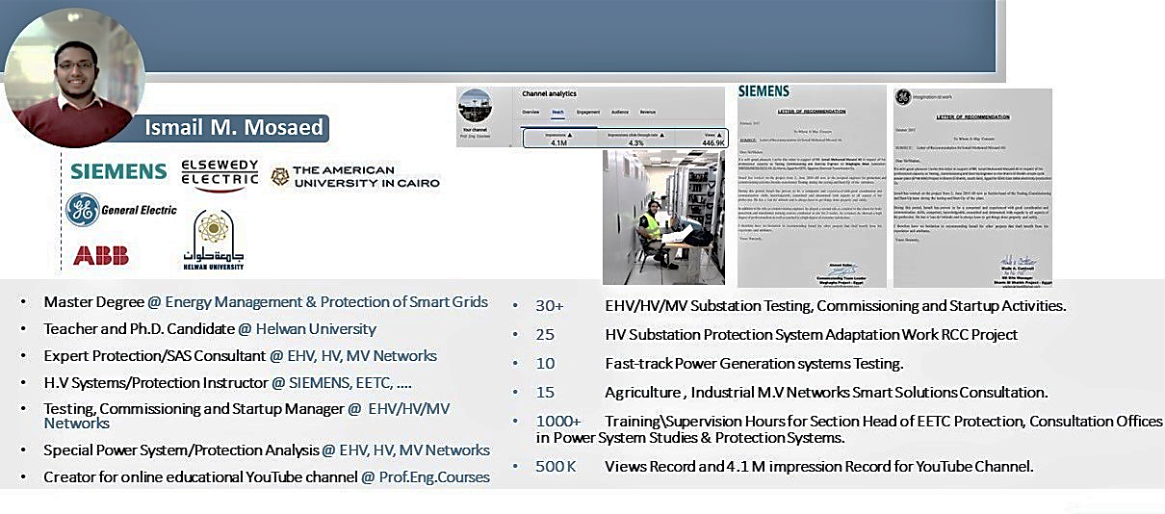

Google Scholar: https://scholar.google.com/citations?user=miraxC8AAAAJ&hl=en

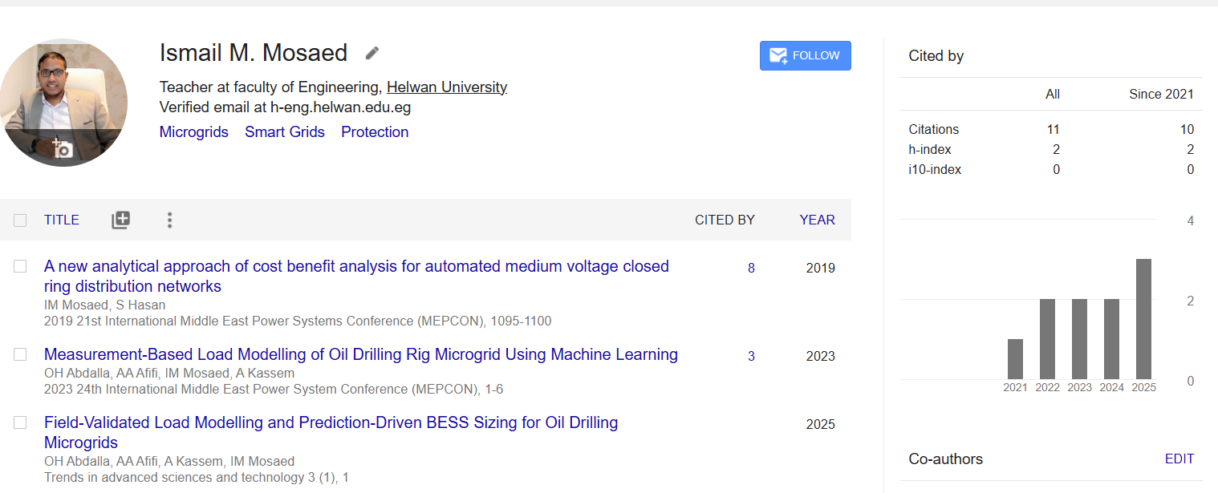

Education:
- Degree - Year: Engineering Bachelor in Electrical power and machines – 2013, Helwan University
- Master Degree: Automatic Operation of Medium Voltage Closed Ring Distribution Networks, 2020.
- PhD Degree: “Optimal Operation of Isolated Microgrids”, 2026.
- Graduation Project: Substation Protection and Control, 100 % - Excellent.
- Cumulative Grade: 90.5 % - Excellent (with honor degree).

Key Achievements:

- Technical Consultant in Mega-Projects, Renewable Energy, Green Hydrogen and HVDC connecting Egypt/KSA, .etc. some projects are as follows:
- Configuration of Protection Systems, BCUs and Development of CID files (Configuration & Interoperability Description) for 3GW HVDC Link Egypt-KSA, Badr 500kV Converter station.
- Led full techno-economic feasibility assessment for interconnecting remote oil fields (Al-Razzak) to centralized power sources, evaluating MV OHL, MV underground cables, HV grid connection, PV/BESS, and hybrid PV/BESS with 5 MW gas turbine integration.
- Developed performance guarantee frameworks for renewable microgrids within PPA agreements, covering PV, BESS, and diesel backup systems supplying 25 MVA at 0.85 PF for oil field operations.
- Acted as Owner’s Consultant during predevelopment phase for grid interconnection strategy, defining technical evaluation criteria, system alternatives, and financial viability metrics.
- Delivered voltage sag immunity, protection coordination, and transformer tapping studies for critical MV/LV industrial loads in Digital City infrastructure.
- Designed and supervised protection settings and coordination schemes including REF615 and REG615 relays by ABB, covering transformer protection, frequency backup protection, short-circuit protection, and MV/LV over/undervoltage protection.
- Reviewed and optimized synchronization, inter-tripping, and interlocking schemes for MV switchgear and turbine-generator systems in industrial facilities.
- Evaluated and revised operational scenarios and protection supervision logic for WHR turbine integrated within cement plant operations.
- Developed methodology for transformer–converter compatibility verification in renewable and power electronic applications, ensuring cross-supplier technical alignment.
- Conducted evaluation and technical comparison of multiple 22 kV and 33 kV connection proposals, including long-route MV cables (up to 53 km), reactive compensation solutions (shunt reactors, capacitor banks, SVC), and voltage control strategies.
- Prepared comprehensive technical and commercial proposals for EPC contractors and energy developers, integrating engineering analysis with contractual risk mitigation.
- Published peer-reviewed research on smart distribution networks, microgrid control, and BESS integration strategies for oil drilling applications, integrating machine learning-based optimization.
- Designed microgrid control strategies integrating PV, BESS, diesel generation, and flared gas turbines to enhance reliability, fuel reduction, and grid independence.
- Laboratory Development & Strategic Funding
- Secured major capital funding from multinational industry leaders including Siemens (Germany), Schneider Electric (France), and ABB (Switzerland) to modernize Faculty of Engineering laboratories, Helwan university.
- Authored winning technical proposals that resulted in the successful acquisition of three separate development grants.
- Creator for YouTube channel (Prof.eng.courses) “Educational Channel” https://www.youtube.com/channel/UCIYX6HP2kE0LPWFdxN_kDUw/playlists Contains more than 250 educational videos and 732,100 Views.
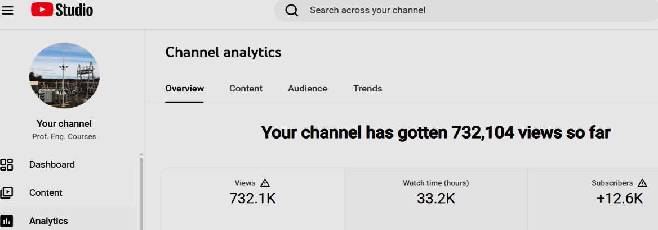
Computer / Software Skills:
- Excellent knowledge of Office Package (Word, Excel, PowerPoint).
- Electrical Engineering Design and Testing Software Packages such as:
No. | Software | No. | Software
1 | ETAP Power System Analysis Software, | 12 | AutoCAD
2 | Neplan Power System Analysis Software, | 13 | PSCAD
3 | HMI500 – ABB Busbar Protection Software, | 14 | MATLAB
4 | SFT2841 – Schneider Software, | 15 | Sag10 Software
5 | Digsi-4 – Siemens Software, | 16 | ISA DRTS Software
6 | Digsi-5 – Siemens Software, | 17 | Frejawin Software
7 | Omicron CT Analyzer Software, | 18 | Powerdb Software
8 | GE F650 Series Software, | 19 | Simgrid Software
9 | S1 Agile – Micom Software, | 20 | Enervista – GE Software,
10 | Omicron CMC356 Software, | 21 | Tapcon260 MR Software,
11 | Metercat Elster Software, | 22 | PCM600- ABB Software,

Recommendation Letters:
- Some Satisfaction and Recommendation Letters

_{Thanks for your time}

